**Headbop – Updated Coding Scheme**

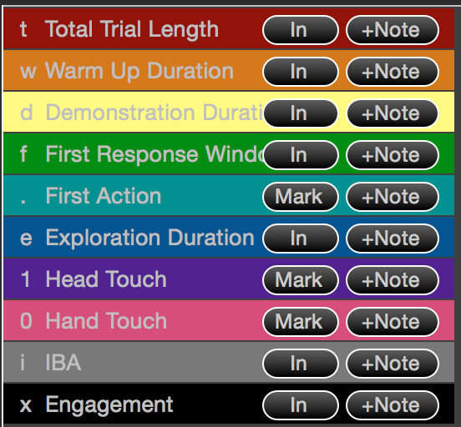

**Total Trial Length (t)** – when parent sits with child in lap; when parent stands.

**Warm Up Duration (w)** – when trial begins; when doll is put away

**Demonstration Duration (d)** – when toy is placed on table; at moment the toy is

pushed toward child

**First Response Window (f)** – when toy is being pushed toward child; when

experimenter begins to stand up

**Exploration Duration (e)** – when experimenter begins to stand up; when experimenter

turns to return to table

**Engagement (x) –** any combination of: (1) **looking** at the toy (at least at the start); (2)

**touching** the toy; (3) **discussing** the toy in some capacity (e.g. talking about it

directly, asking for parent’s help to fix it, etc.)

***Intentional Body Actions*** –include physical contact with the toy, which is not exclusive to the globe, and looking at the toy *at the start* (but not necessarily for all) of the contact period.

***Attempts*** – include intentional actions separated by 1-second delays (and apply to both head and hand touches)

**On the first pass, code for:**

1. General **event windows** (e.g. warm-up, first response, etc)
2. First **intentional body actions** (note when they appear in regards to event windows
3. General **engagement**

**In future passes, code for:**

1. All other instances of intentional body action (noting time, number and duration; possibly also alternation or pattern sequence?)
2. Incomplete attempts
3. More detailed description of engagement